DTSC-671 – AI Solution in the Cloud
Module 5 – Forecasting

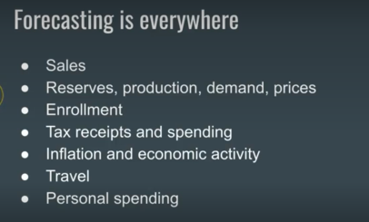

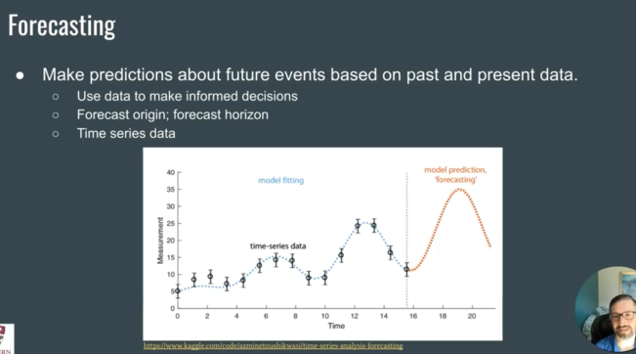
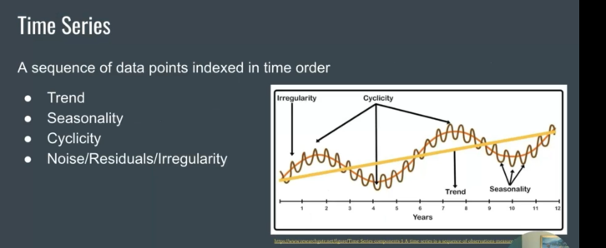
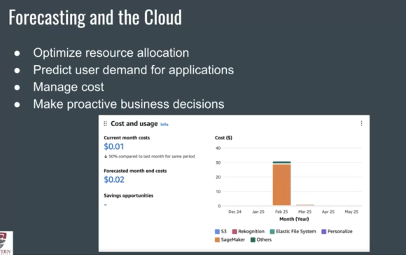
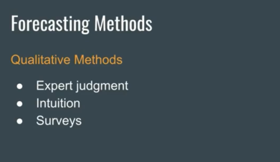
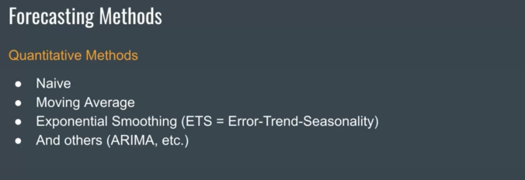
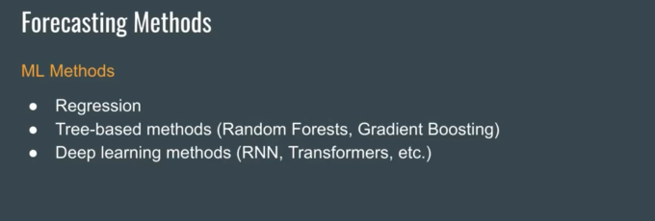
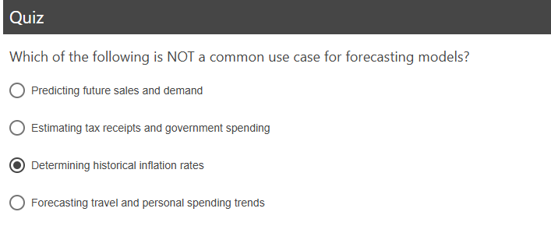

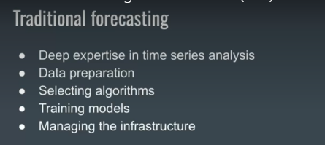
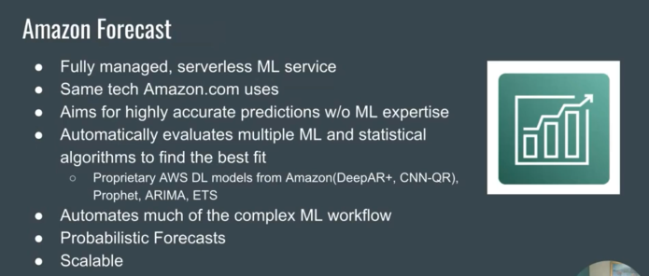
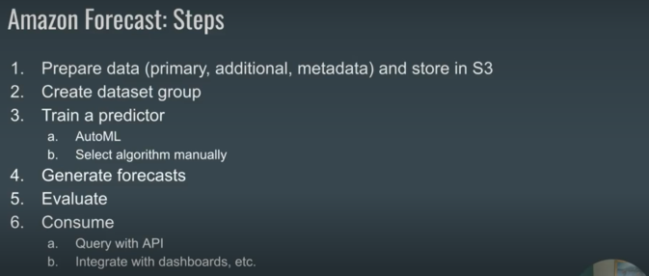
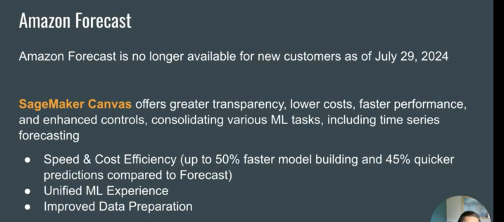
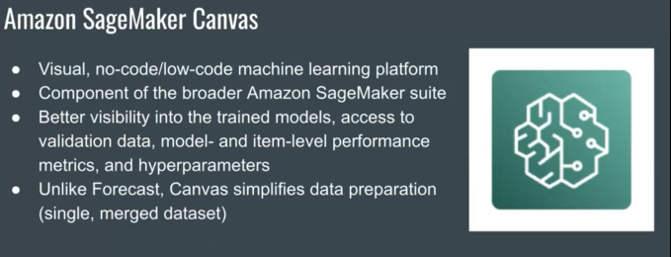
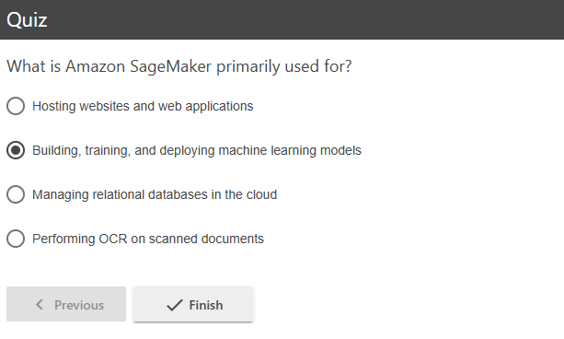
*** Test Question
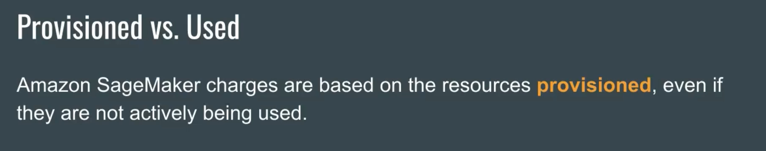


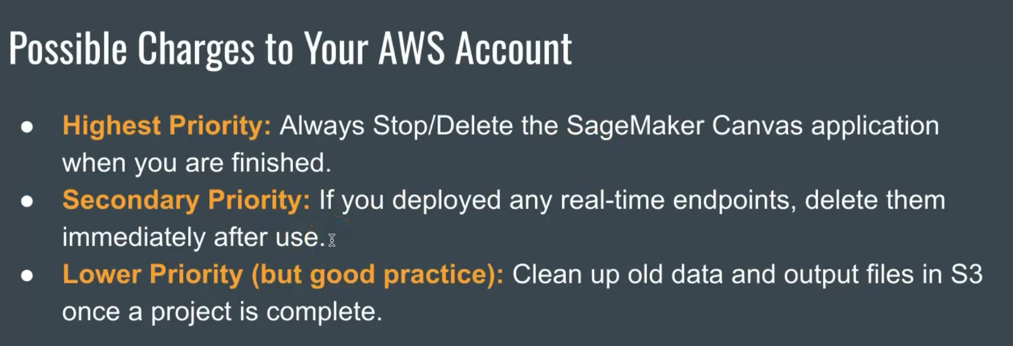
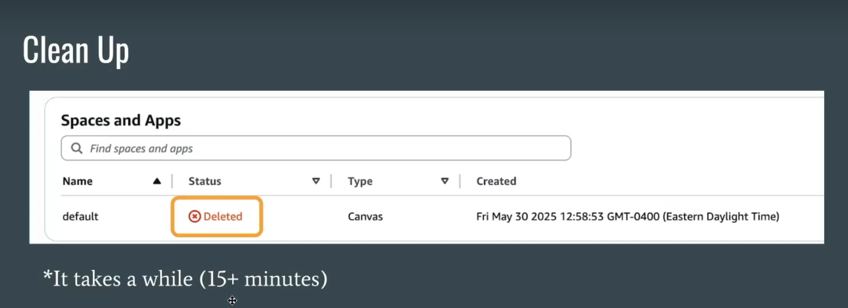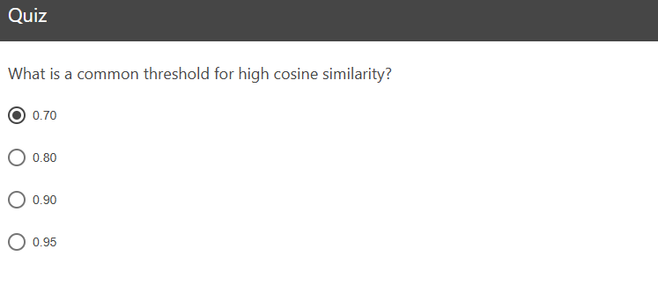

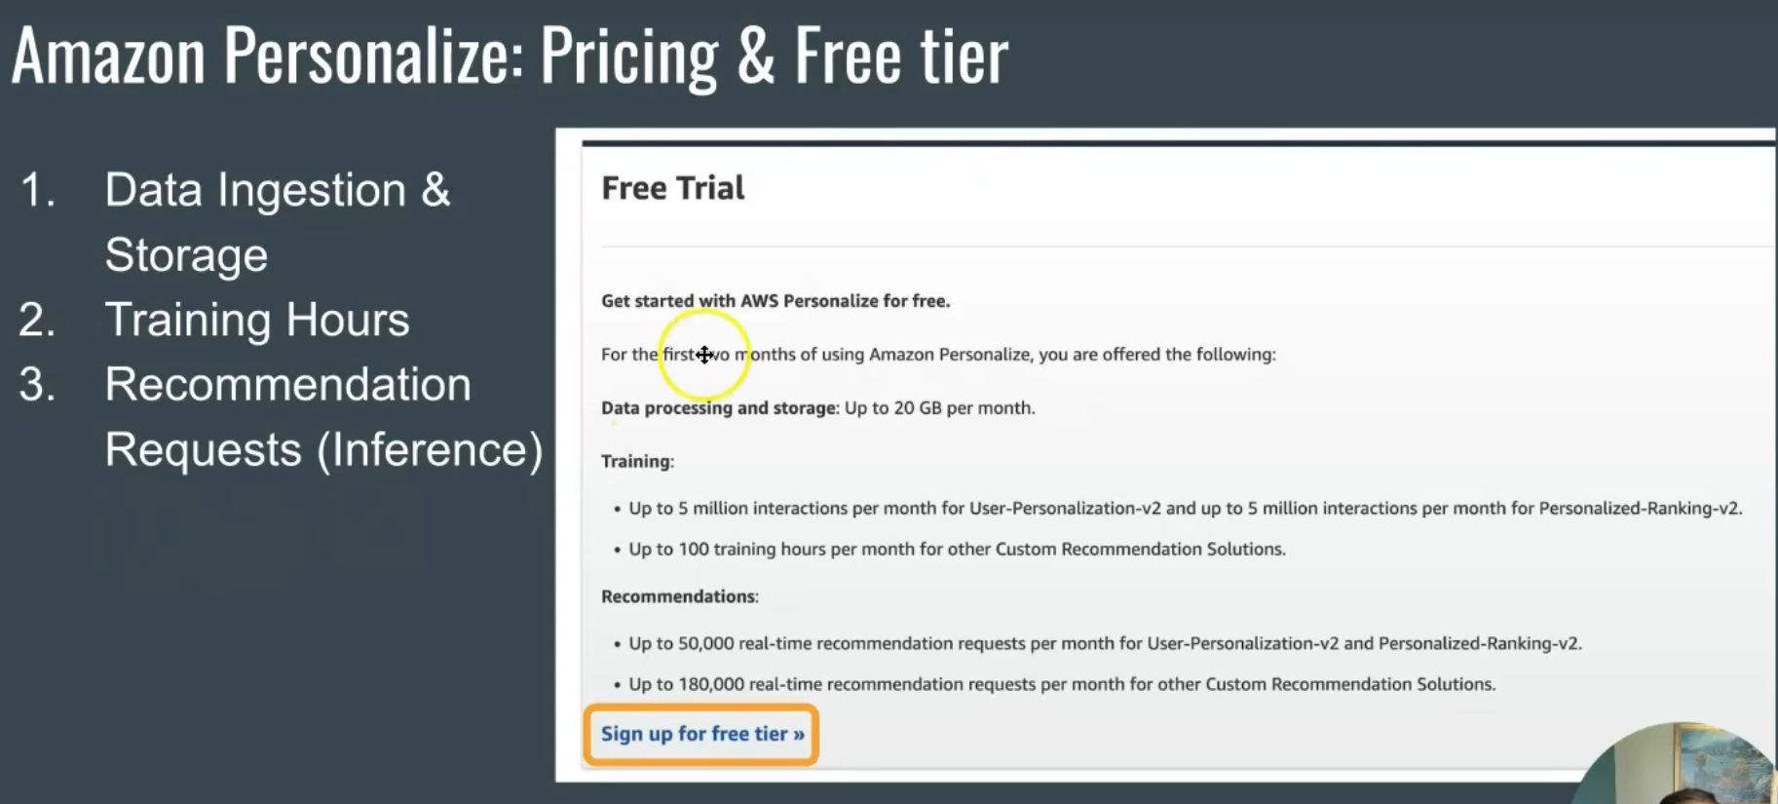
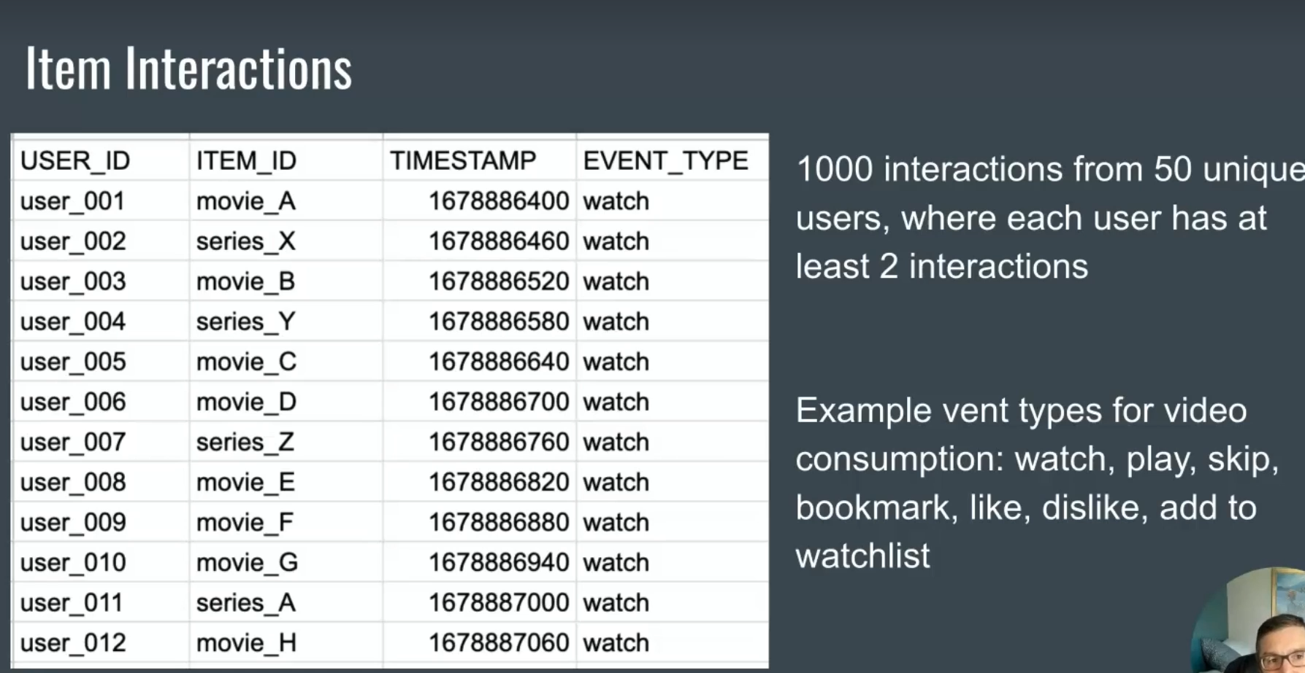
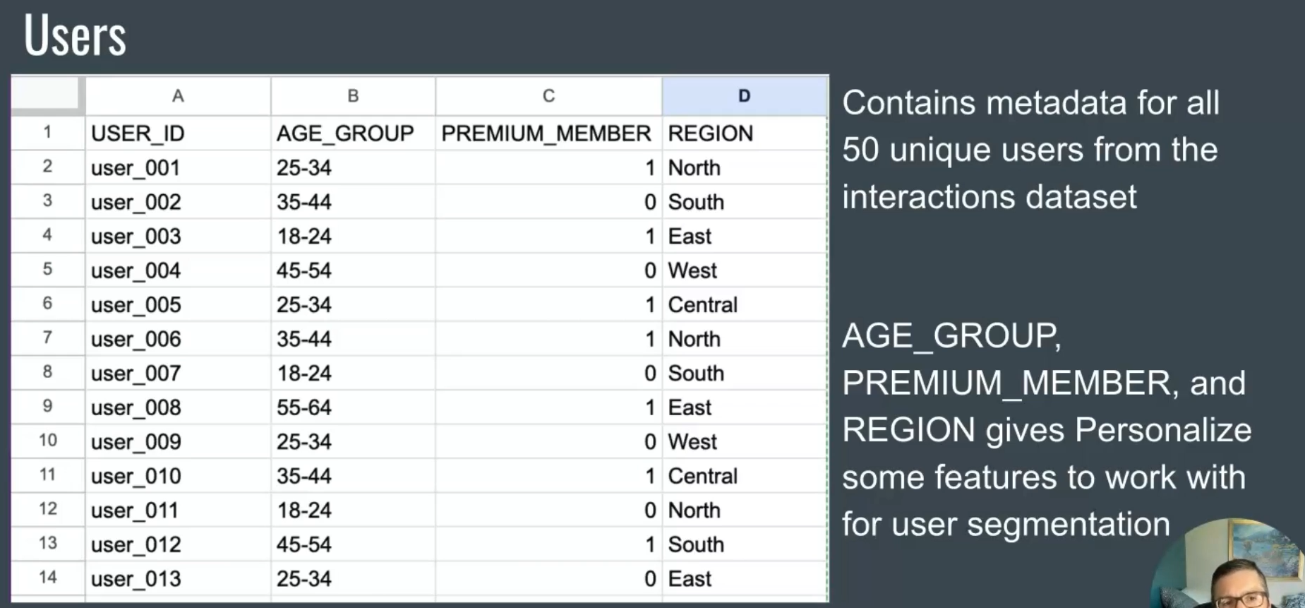
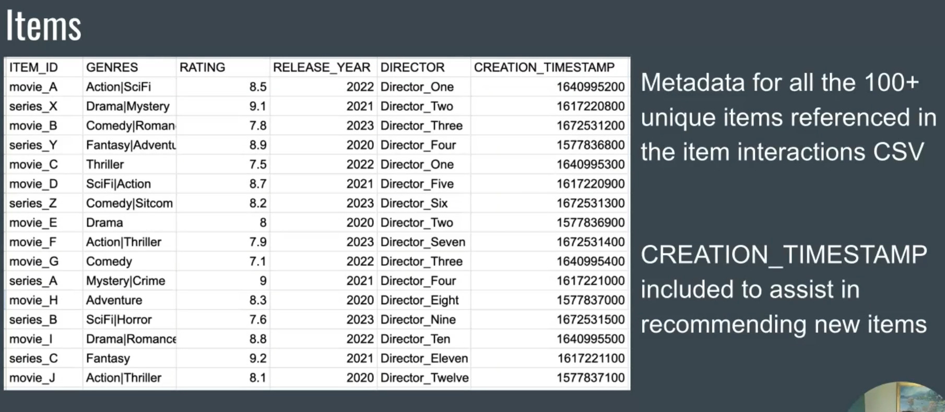
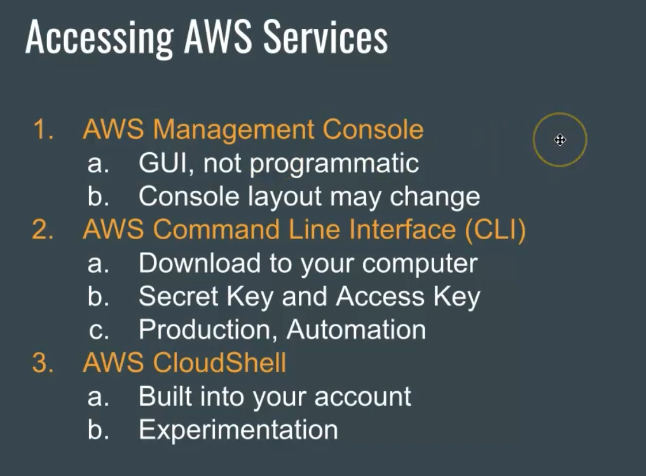
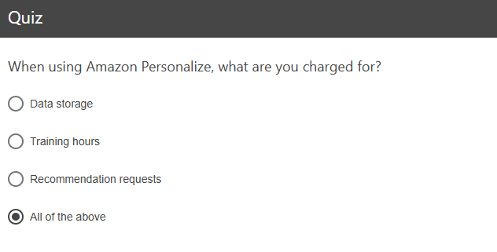

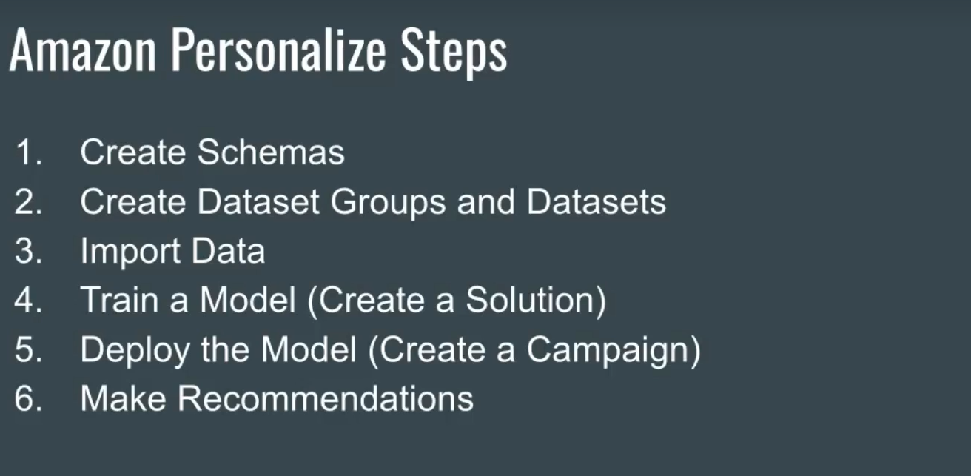
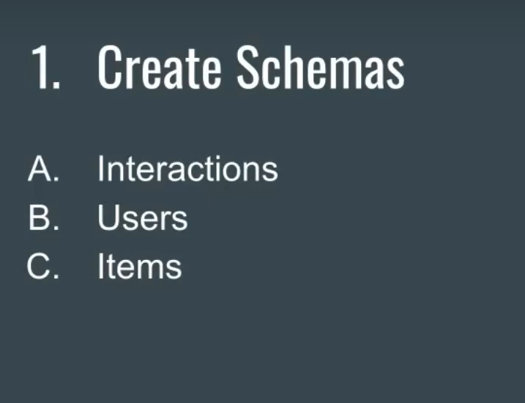

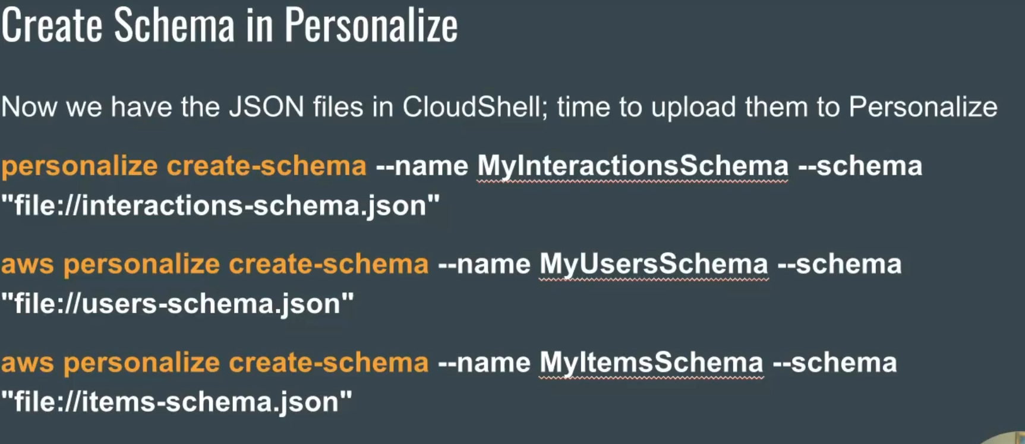
aws personalize create-schema --name MyInteractionsSchema --schema "file://interactions-schema.json"
aws personalize create-schema --name MyUsersSchema --schema "file://users-schema.json"
aws personalize create-schema --name MyItemsSchema --schema "file://items-schema.json"

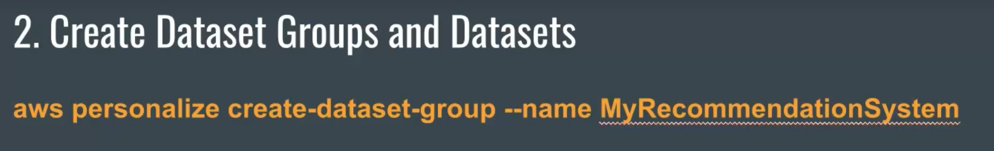
~ $ aws personalize create-dataset-group --name MyRecommendationSystem
{
"datasetGroupArn": "arn:aws:personalize:us-east-2:548722509238:dataset-group/MyRecommendationSystem"
}
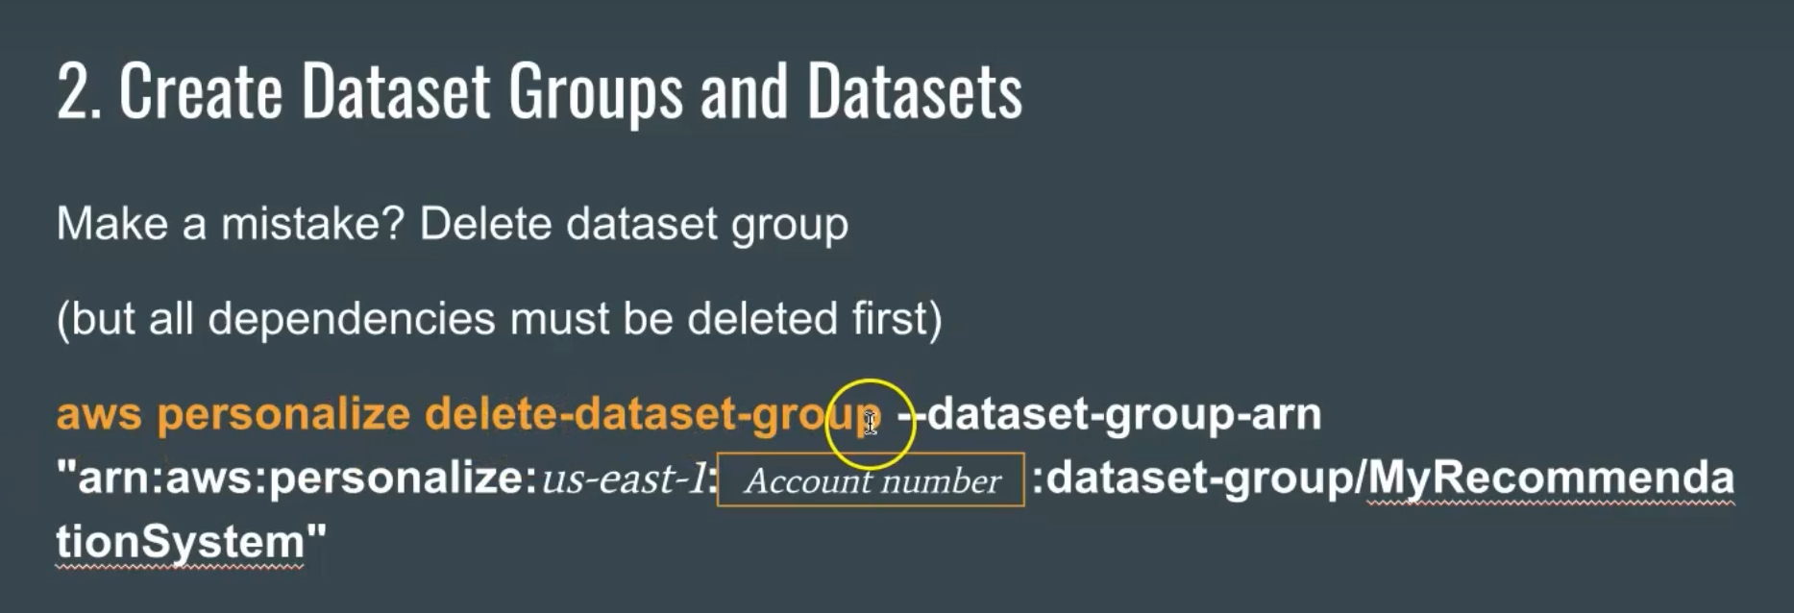
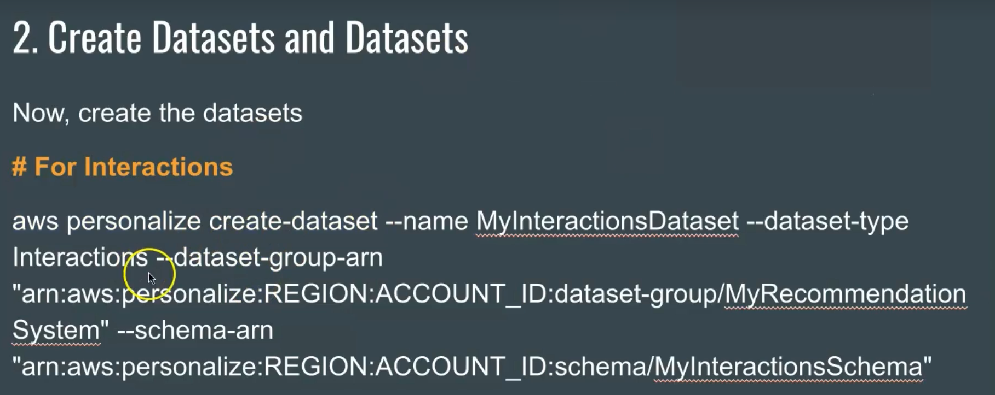
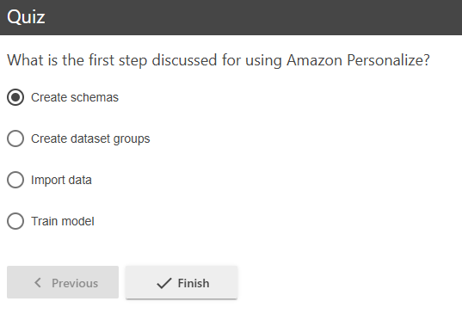
aws personalize create-schema --name MyInteractionsSchema --schema "file://interactions-schema.json"
aws personalize create-schema --name MyUsersSchema --schema "file://users-schema.json"
aws personalize create-schema --name MyItemsSchema --schema "file://items-schema.json"

~ $ aws personalize create-schema --name MyInteractionsSchema --schema "file://interactions-schema.json"
{
"schemaArn": "arn:aws:personalize:us-east-2:548722509238:schema/MyInteractionsSchema"
}
~ $ aws personalize create-schema --name MyUsersSchema --schema "file://users-schema.json"
{
"schemaArn": "arn:aws:personalize:us-east-2:548722509238:schema/MyUsersSchema"
}
~ $ aws personalize create-schema --name MyItemsSchema --schema "file://items-schema.json"
{
"schemaArn": "arn:aws:personalize:us-east-2:548722509238:schema/MyItemsSchema"
}
~ $ aws personalize create-dataset --name MyInteractionsDataset --dataset-type Interactions --dataset-group-arn "arn:aws:personalize:us-east-2:548722509238:dataset-group/MyRecommendationSystem" --schema-arn "arn:aws:personalize:us-east-2:548722509238:schema/MyInteractionsSchema"
~ $ aws personalize create-dataset --name MyUsersDataset --dataset-type Users --dataset-group-arn "arn:aws:personalize:us-east-2:548722509238:dataset-group/MyRecommendationSystem" --schema-arn "arn:aws:personalize:us-east-2:548722509238:schema/MyUsersSchema"
~ $ aws personalize create-dataset --name MyItemsDataset --dataset-type Items --dataset-group-arn "arn:aws:personalize:us-east-2:548722509238:dataset-group/MyRecommendationSystem" --schema-arn "arn:aws:personalize:us-east-2:548722509238:schema/MyItemsSchema"

~ $ aws personalize create-dataset --name MyInteractionsDataset --dataset-type Interactions --dataset-group-arn "arn:aws:personalize:us-east-2:548722509238:dataset-group/MyRecommendationSystem" --schema-arn "arn:aws:personalize:us-east-2:548722509238:schema/MyInteractionsSchema"
{
"datasetArn": "arn:aws:personalize:us-east-2:548722509238:dataset/MyRecommendationSystem/INTERACTIONS"
}
~ $ aws personalize create-dataset --name MyUsersDataset --dataset-type Users --dataset-group-arn "arn:aws:personalize:us-east-2:548722509238:dataset-group/MyRecommendationSystem" --schema-arn "arn:aws:personalize:us-east-2:548722509238:schema/MyUsersSchema"
{
"datasetArn": "arn:aws:personalize:us-east-2:548722509238:dataset/MyRecommendationSystem/USERS"
}
~ $ aws personalize create-dataset --name MyItemsDataset --dataset-type Items --dataset-group-arn "arn:aws:personalize:us-east-2:548722509238:dataset-group/MyRecommendationSystem" --schema-arn "arn:aws:personalize:us-east-2:548722509238:schema/MyItemsSchema"
{
"datasetArn": "arn:aws:personalize:us-east-2:548722509238:dataset/MyRecommendationSystem/ITEMS"
}

arn:aws:iam::548722509238:role/PersonalizeS3BucketAccess

s3://dtsc-671-personalize-streaming-fa1-2026-cnielson/item_interactions_streaming.csv
s3://dtsc-671-personalize-streaming-fa1-2026-cnielson/items_streaming.csv
s3://dtsc-671-personalize-streaming-fa1-2026-cnielson/users_streaming.csv

~ $ aws personalize create-dataset-import-job --job-name MyInteractionsImportJob --dataset-arn "arn:aws:personalize:us-east-2:548722509238:dataset/MyRecommendationSystem/INTERACTIONS" --data-source "dataLocation=s3://dtsc-671-personalize-streaming-fa1-2026-cnielson/item_interactions_streaming.csv" --role-arn "arn:aws:iam::548722509238:role/PersonalizeS3BucketAccess"
~ $ aws personalize create-dataset-import-job --job-name MyUsersImportJob --dataset-arn "arn:aws:personalize:us-east-2:548722509238:dataset/MyRecommendationSystem/USERS" --data-source "dataLocation=s3://dtsc-671-personalize-streaming-fa1-2026-cnielson/users_streaming.csv" --role-arn "arn:aws:iam::548722509238:role/PersonalizeS3BucketAccess"
~ $ aws personalize create-dataset-import-job --job-name MyItemsImportJob --dataset-arn "arn:aws:personalize:us-east-2:548722509238:dataset/MyRecommendationSystem/ITEMS" --data-source "dataLocation=s3://dtsc-671-personalize-streaming-fa1-2026-cnielson/items_streaming.csv" --role-arn "arn:aws:iam::548722509238:role/PersonalizeS3BucketAccess"

~ $ aws personalize create-dataset-import-job --job-name MyInteractionsImportJob --dataset-arn "arn:aws:personalize:us-east-2:548722509238:dataset/MyRecommendationSystem/INTERACTIONS" --data-source "dataLocation=s3://dtsc-671-personalize-streaming-fa1-2026-cnielson/item_interactions_streaming.csv" --role-arn "arn:aws:iam::548722509238:role/PersonalizeS3BucketAccess"
{
"datasetImportJobArn": "arn:aws:personalize:us-east-2:548722509238:dataset-import-job/MyInteractionsImportJob"
}
~ $ aws personalize create-dataset-import-job --job-name MyUsersImportJob --dataset-arn "arn:aws:personalize:us-east-2:548722509238:dataset/MyRecommendationSystem/USERS" --data-source "dataLocation=s3://dtsc-671-personalize-streaming-fa1-2026-cnielson/users_streaming.csv" --role-arn "arn:aws:iam::548722509238:role/PersonalizeS3BucketAccess"
{
"datasetImportJobArn": "arn:aws:personalize:us-east-2:548722509238:dataset-import-job/MyUsersImportJob"
}
~ $ aws personalize create-dataset-import-job --job-name MyItemsImportJob --dataset-arn "arn:aws:personalize:us-east-2:548722509238:dataset/MyRecommendationSystem/ITEMS" --data-source "dataLocation=s3://dtsc-671-personalize-streaming-fa1-2026-cnielson/items_streaming.csv" --role-arn "arn:aws:iam::548722509238:role/PersonalizeS3BucketAccess"
{
"datasetImportJobArn": "arn:aws:personalize:us-east-2:548722509238:dataset-import-job/MyItemsImportJob"
}

Personalize built of business users not data scientists. The call training the model, creating a solution and deploying the model, building a campaign
